Extended Profiles Including Surface-Layer Wind Speed Improve

Farm-Scale Wind Power Forecasting
Xin Xia^{1,*}, Yong Luo^{1,*}, Rui Chang², Martin Dörenkämper³, Rong Zhu^{1,2}, Kun Yang¹, Peidu Li⁴, Xiaoli Zhang⁵
¹Ministry of Education Key Laboratory for Earth System Modeling, Department of Earth System Science, Tsinghua University, Beijing 100084, China
²National Climate Center of China Meteorological Administration (CMA), Beijing 100081, China
³Fraunhofer Institute for Wind Energy Systems, Küpkersweg70, 26129 Oldenburg, Germany
⁴Plateau Atmosphere and Environment Key Laboratory of Sichuan Province, School of At-mospheric Sciences, Chengdu University of Information Technology, Chengdu 610225, China
⁵HUADIAN NEW ENERGY GROUP CO.,LTD.LIAONING BRANCH, Shenyang 110000, China

*Corresponding author: Xin Xia (xiax24@mails.tsinghua.edu.cn) and Yong Luo (Yongluo@tsinghua.edu.cn)

Key Points:
- Farm-scale wind power is better represented by vertical wind profiles extending below the rotor-swept layer.
- Under free-stream flow, full vertical profile matters, whereas under wake-influenced flow surface wind indicates profile intensity.
- Extended profiles improve power reconstruction, and a wind-direction-aware strategy enhances day-ahead forecasting.

Abstract
Wind farm power production reflects atmospheric variability across height and time scale, yet most forecasting approaches rely on wind speed at a single hub height. While rotor-equivalent wind speed accounts for variability within the rotor-swept layer, observations from a flat-terrain wind farm show that the profile relevant to farm-scale power extends below this layer. Partitioning observations by inflow regime reveals distinct mechanisms: under free-stream conditions, 10-m and 70-m winds provide complementary information for characterizing vertical structure, whereas under wake-influenced conditions, 10-m wind represents inflow profile intensity. This effectiveness arises from strong vertical coherence at synoptic time scales, enabling 10-m wind to characterize overall profile intensity across regimes, while rotor-swept layer winds become less reliable under wake-influenced conditions. An extended profile representation demonstrates consistent gains in power reconstruction and NWP-driven day-ahead forecasting. These results clarify how vertical wind structure governs farm-scale power and inform wind-to-power representation in operational forecasting.

Plain Language Summary
Wind turbines generate electricity from wind blowing across their blades, so knowing how wind varies with height is essential for predicting wind farm power. Most forecasts rely on wind measured at a single height near the middle of the turbine rotor, but this can miss important information. When turbine wakes disturb winds at rotor height, near-surface winds remain largely unaffected and better reflect the broader atmospheric conditions that control how much power the farm can produce. This is because winds at different heights tend to strengthen and weaken together over the hours-to-days time scales most relevant for power generation. By combining wind measurements from near the surface and the rotor layer, we improved both power estimates based on observations and day-ahead power forecasts. These findings suggest that existing weather towers and surface observations near wind farms can be used more effectively, and may also help inform how observational networks are designed and used for wind energy applications.

1 Introduction
Accurate day-ahead wind power forecasting is essential for power-system operation, electricity market, and the large-scale integration of variable renewable energy (Holttinen, 2005; Mahoney et al., 2012). Forecasting performance has been substantially advanced in recent years, including through the development of deep learning models (Liu & Zhang, 2024), and depends not only on model capability but fundamentally on the physical relevance of meteorological inputs (Optis & Perr-Sauer, 2019). Previous research has largely focused on model development, including architecture innovation (Bentsen et al., 2023), hyperparameter optimization (Hanifi et al., 2024), and post-processing (Xia et al., 2026b). In comparison, input feature selection has received less mechanistic consideration. Consequently, the atmospheric physics governing farm-scale power production is increasingly well understood. However, this understanding has not yet been effectively translated into forecasting feature selection, particularly for vertical wind structure represented by commonly available multi-height observations.
Traditionally, wind speed at hub height has been the primary input for wind power forecasting (Mahoney et al., 2012; Ye et al., 2017; Che et al., 2022; Sun & Yang, 2023), reflecting a simplified representation of atmospheric inflow consistent with the single-turbine power curve, where power can be characterized by a single hub-height wind speed (Turbines—Part, 2005). This practice is further supported by the strong correlation between hub-height wind speed and single-turbine power (Clifton et al., 2013). At the wind farm scale, however, this simplification becomes insufficient because aggregate power depends not only on the inflow at individual turbines but also on wake interactions across the farm (Barthelmie et al., 2010). Wake development and recovery are strongly influenced by boundary-layer structure, including wind shear, turbulence, and atmospheric stability (Abkar & Porté-Agel, 2015). As a result, forecasting based solely on hub-height wind speed often fails to fully capture the atmospheric drivers of farm-scale power variability. Physical studies have demonstrated that rotor-equivalent wind speed (REWS) (Wagner et al., 2009), which integrates wind speeds across the rotor-swept layer, outperforms single-height measurements in forecasting farm-scale power (Sasser et al., 2022). Even with this advance, atmospheric stability can induce 15–20% power variations at the same nominal wind speed, and turbulent kinetic energy has been identified as a dominant modulation factor (Wharton & Lundquist, 2012). Confining vertical integration to the rotor-swept layer therefore remains insufficient to capture the influence of vertical structure and its governing scales on farm-scale power variability.
Flow-regime variability adds another dimension to farm-scale power representation. Wind farms operate in environments that encompass both free-stream inflow and wake-influenced flow, within which the dominant drivers of power production differ. Wake interactions can cause 10–20% power losses and elevate turbulence intensity (Barthelmie et al., 2007; Feroz et al., 2020), implying that the physical controls on power output vary dynamically with flow regime and atmospheric stability. Recent explainable-AI analyses also rank turbulence-related variables, including turbulent kinetic energy and turbulence intensity, among the most informative predictors of farm-scale power, second only to wind speed (Optis & Perr-Sauer, 2019; Kim & Kim, 2023), further suggesting regime-dependent modulation of inflow–power relationships. Yet data-driven forecasting models commonly incorporate multi-height meteorological inputs as homogeneous predictors, without explicitly accounting for flow-regime-dependent mechanisms. When distinct flow regimes are aggregated, underlying physical differences can manifest as persistent empirical correlations that lack clear physical interpretation. One such example is the consistently reported high correlation between near-surface wind speeds (e.g., 10-m wind) and total wind-farm power output (Rubanenko et al., 2020; Chen & Xu, 2022), whose physical basis remains unclear.
In this study, we link atmospheric flow physics to farm-scale power forecasting by explicitly partitioning inflow regimes and examining the regime-dependent roles of multi-height wind observations spanning 10 to 70 m, from near-surface to hub-height levels. Using multi-height observations from a representative flat-terrain wind farm, we quantify how vertical wind structure governs power variability under free-stream and wake-influenced conditions, thereby clarifying the physical origin of the persistent high correlation between near-surface winds and total farm power. We show that incorporating regime-dependent profile information outperforms both single hub-height input and undifferentiated multi-height predictors in observational power reconstruction and Numerical Weather Prediction (NWP)-driven day-ahead forecasting. By revealing that governing atmospheric time scales and vertical coherence underpin the relevance of non-hub-height winds to farm-scale power, the results provide a mechanistic basis for improving wind-to-power representation in operational forecasting.

2 Materials and Methods

2.1 Flow Regime Classification
Flow regimes were classified based on wind direction relative to the turbine layout (Figure 1 shows the turbine layout and mast location). Westerly winds (225°–315°) are classified as free-stream conditions, under which measurements represent background atmospheric flow upstream of the turbine array. In contrast, easterly winds (45°–135°) traverse the turbine array before reaching the mast and are therefore classified as wake-influenced conditions, under which wind profiles are affected by turbine-induced momentum deficits and enhanced turbulence (Porté-Agel et al., 2020). Regime classification is based solely on geometric wind-direction criteria relative to turbine layout and does not impose additional buffer zones near sector boundaries. To ensure high regime purity and exclude transitional or vertically sheared directional states, regime assignment required consistent wind direction across all four measurement heights (10 m, 30 m, 50 m, and 70 m). This stringent filtering reduces the number of retained samples but enhances the physical interpretability of regime-dependent analysis. Over the study period, the resulting dataset comprises 1,951 free-stream samples (3.7%) and 8,693 wake-influenced samples (16.6%), with the remaining observations excluded from regime-specific evaluation.

2.2 Data Analysis Methods
Complete Ensemble Empirical Mode Decomposition with Adaptive Noise (CEEMDAN; Torres et al., 2011), an improved variant of EEMD (Wu & Huang, 2009) was applied to the continuous wind speed (at different heights) and total farm power time series to obtain intrinsic mode functions across temporal scales. Regime-dependent wind–power coupling was quantified by computing cross-scale correlations within subsets of timestamps classified into free-stream and wake-influenced conditions based on wind direction (Text S1). Empirical Orthogonal Function (EOF) analysis was performed on wind profiles to identify dominant modes of vertical structure variability (Wilson, 1996). The first EOF mode (EOF1) represents the leading spatial pattern, and its principal component time series (PC1) quantifies temporal amplitude (Wilks, 2011). Least-squares linear regression between PC1 and wind speeds at 10 m or 70 m quantifies how effectively surface-layer or hub-height observations capture vertical profile variability. Further details on the decomposition and EOF methodologies are provided in Texts S1 and S2.

2.3 Power Reconstruction Experiment
To evaluate whether the extended profile representation improves wind farm power prediction, a reconstruction experiment was conducted using observed meteorological variables and observed farm-scale power output. A LightGBM regression model (Ke et al., 2017) was trained to learn the relationship between wind measurements and total power production. Three input configurations were tested: hub-height wind speed only (HH, 70 m), Standard REWS integrating wind speeds within the rotor-swept layer (SR, 30–70 m), and Extended REWS incorporating surface-layer wind speed (ER, 10–70 m). Models were trained on a subset of the observational dataset and evaluated on withheld test samples. Performance was assessed on the full test set and separately on test samples under free-stream and wake-influenced conditions. Full implementation details, including model hyperparameters, data filtering, and train–test splitting procedures, are documented in Text S3. To examine whether the regression model exploits physically meaningful information rather than statistical artifacts, SHapley Additive exPlanations (SHAP) were applied to quantify the contribution of each input variable (Lundberg & Lee, 2017). SHAP analysis was conducted separately for free-stream and wake-influenced conditions to assess whether variable importance aligns with the regime-dependent vertical structure identified in Section 4.1.

2.4 Day-Ahead Forecast Experiment
To assess operational relevance, day-ahead forecasting experiments were conducted using meteorological variables predicted by the WRF model. Following common practice (Cassola & Burlando, 2012), predicted variables were bias-corrected against observations before being used for power prediction. The same three input configurations evaluated in the reconstruction experiment—hub-height wind speed only (HH), Standard REWS integrating wind speeds within the rotor-swept layer (SR), and Extended REWS including surface-layer wind speed (ER)—were applied to the bias-corrected WRF outputs. Temperature was included as a predictor in all configurations (Text S4).
In addition to these baseline configurations, a sector-based forecasting experiment was implemented to reflect regime-dependent behavior. Forecasts were partitioned into free-stream conditions (225°–315°), wake-influenced conditions (45°–135°), and transitional directions (remaining sectors) based on 70-m wind direction predicted by WRF. During forecasting, the sector was determined from the predicted wind direction, and the corresponding sector-specific model was applied. This sector-based forecasting experiment is referred to as the wind-direction-aware (WDA) approach in the following sections. The input variables for each sector were determined based on SHAP-derived feature importance from the reconstruction experiment (Section 4.3): for the free-stream sector, wind speeds at 10 m, 50 m, and 70 m were used; for the wake-influenced sector, wind speeds at 10 m, 30 m, and 70 m were used; for the transitional sector, wind speeds at all four heights were used. In all sectors, 10-m temperature was included as an additional predictor. Full implementation details are documented in Text S4.
All four forecasting strategies followed a two-stage learning framework. In the first stage, each meteorological variable was individually bias-corrected using a LightGBM model trained to map WRF outputs to the corresponding observed variable. In the second stage, the bias-corrected meteorological variables were used as inputs to a separately trained LightGBM power prediction model. For the HH, SR, and ER strategies, a single power model was trained on the full dataset using the respective input configurations. For the WDA strategy, three independent power models were trained separately within the free-stream, wake-influenced, and transitional sectors using the ER input configuration; during prediction, the sector was determined from the WRF-predicted 70-m wind direction, and the corresponding model was applied.

2.5 Statistical Testing
Model performance was evaluated using coefficient of determination (R²), root mean square error (RMSE), and Spearman correlation coefficient computed against observed farm-scale power output. Statistical significance of performance differences between modeling strategies was assessed using the Diebold-Mariano test (Diebold & Mariano, 1995), which accounts for temporal autocorrelation in forecast errors when comparing predictive accuracy of competing models.

3 Data

3.1 Site and Observational Data
Observational data were collected from a 201 MW wind farm located on flat terrain in the desert Gobi of the Hexi Corridor, Gansu, China (96.8114°E, 40.2053°N). The farm comprises 134 wind turbines, each with a rated capacity of 1.5 MW, a hub height of 61.5 m, and a rotor diameter of 82 m. A 70 m meteorological mast is situated 586 m west of the first turbine row at the western boundary of the farm (Figure 1). Vertical wind profiles were characterized using wind speed measurements from cup anemometers at four heights (10 m, 30 m, 50 m, and 70 m), provided by the operator, from May 2021 to October 2022 at 15-minute intervals. In this study, the 10 m measurement represents the surface layer, while the 70 m level is used as a near-hub-height reference because it is the closest available measurement height to the turbine hub height.
All observational data underwent a standardized quality-control and preprocessing procedure consistent with that described in Xia et al. (2026a; 2026b). Briefly, missing or invalid values were identified and removed. Short gaps (≤ 2 consecutive time steps) were filled using linear interpolation, while longer gaps were excluded from model training and evaluation. Physically implausible wind speeds (outside 0–30 m s⁻¹) and statistical outliers exceeding three standard deviations from monthly means were removed. All observational records were temporally synchronized with WRF outputs to ensure exact alignment for forecasting experiments. No additional filtering (e.g., removal of low-wind or curtailment periods) was applied in order to preserve realistic operational variability.

3.2 NWP Data
Day-ahead forecasting experiments employed two WRF version 4.2 dynamical downscaling datasets initialized from different global forecast systems. The first dataset was driven by the ECMWF Integrated Forecasting System (hereafter EC-WRF), and the second was driven by the NCEP Global Forecast System (hereafter GFS-WRF). Both downscaling systems used identical WRF configurations, including physics parameterizations and nesting strategies, to ensure comparability. Following operational requirements of local grid dispatch centers, forecasts targeting the next-day 24-hour period (Day+1, 00:00–23:45 Beijing Time) were initialized daily at 20:00 Beijing Time. A 28-hour lead time accounts for data transmission, computation, and reporting constraints, with the first 28 hours treated as model spin-up. Forecast hours 28–52 were extracted for evaluation, bilinearly interpolated to the meteorological mast location, and vertically interpolated to the four observation heights (10 m, 30 m, 50 m, and 70 m). The WRF configuration and baseline validation of the operational framework are documented in Xia et al. (2026a), and the same setup is adopted here to ensure methodological consistency.

4 Results and Discussion

4.1. Observational Evidence: Vertical Correlation Structure and Flow-Regime Dependency
The meteorological mast, positioned 586 m west of the western boundary of the wind farm, captures two distinct inflow regimes determined by wind direction. As shown in the wind rose (Figure 2A), westerly winds represent free-stream conditions, whereas easterly winds correspond to wake-influenced conditions. This configuration provides a natural experimental setting for studying the relationship between vertical wind measurements and farm-scale power generation.
Contrary to conventional expectations, analysis of the full dataset shows that 10-m wind speed exhibits a slightly higher Spearman correlation with total farm power (r ≈ 0.81) than hub-height wind speed at 70 m (r ≈ 0.79) (Figure 2B, black line). This result challenges both the reliance on hub-height wind speed and the assumption underlying REWS that wind confined to the rotor-swept layer most effectively represents farm-scale power generation (Mahoney et al., 2012; Wagner et al., 2009; Ye et al., 2017). The complete pairwise Spearman correlation matrix, including inter-height correlations, is provided in Figure S1.
When partitioned by flow regime, this apparent anomaly is resolved. Under free-stream conditions (Figure 2B, red line), correlation increases with height and peaks at 70 m (r ≈ 0.83), consistent with expectations based on vertical shear structure. Under wake-influenced conditions (Figure 2B, blue line), however, correlation at 70 m decreases substantially (r ≈ 0.70), while correlation at 10 m remains high (r ≈ 0.78). The higher overall correlation at 10 m therefore arises from degradation of the hub-height signal under wake-influenced conditions rather than from enhanced predictive power of near-surface wind.
This regime-dependent difference is also reflected in the vertical wind profiles (Figure 2C and 2D). Under free-stream conditions, wind speed increases smoothly from the surface to hub height, consistent with a typical shear structure. Under wake-influenced conditions, wind speeds between 30 m and 70 m are reduced and exhibit larger variability compared with free-stream flow. These changes indicate that turbine-induced momentum extraction and turbulence alter the hub-height wind signal (Barthelmie et al., 2007; Feroz et al., 2020). In contrast, the distribution of 10-m wind speed is nearly identical between free-stream and wake-influenced conditions, suggesting that this level is much less influenced by the wake than the above layer and continues to reflect the background atmospheric inflow.
Collectively, these observations (Figure 2) demonstrate that the higher correlation at 10 m arises from vertical inhomogeneity of wake propagation, with the 10-m level remaining outside cumulative wake effects and thus more representative of the background atmospheric state. This observational evidence provides justification for transitioning from single hub-height measurements to a multi-height representation that includes surface-layer measurements, consistent with the recognition in rotor-equivalent wind speed studies that vertical profile information is essential for accurate power characterization (Wagner et al., 2009; Sasser et al., 2022). However, conventional REWS approaches integrate wind speeds only within the rotor-swept area (typically 30–70 m), neglecting the role of surface-layer observations. These findings motivate the use of an extended profile that incorporates 10-m measurements, recognizing that surface-layer wind can represent farm-scale power variability through vertical atmospheric coupling.

4.2. Scale-Dependent Coupling and Vertical Structure Consistency
Section 4.1 showed that 10-m wind speed remains representative of the background atmospheric state under wake-influenced conditions. Whether 10-m wind can also represent farm-scale power variability depends on the time scales at which power responds and on the degree of vertical coherence (quantified as the Spearman correlation) across heights. If farm-scale power is dominated by variability at time scales where 10-m and rotor-layer winds evolve coherently, then surface-layer wind may capture the relevant atmospheric signal.
Scale-resolved variance analysis (Figure 3A) distinguishes sub-daily wake-related variability from synoptic-scale atmospheric variability. At sub-daily periods, wind-speed variance at 70 m is notably higher under wake-influenced conditions than under free-stream conditions, reflecting additional variability introduced by turbine interactions. In contrast, at synoptic and longer periods, variance levels at 10 m and 70 m become nearly indistinguishable under both free-stream and wake-influenced conditions. This behavior indicates that low-frequency variability is governed primarily by large-scale atmospheric forcing, which exerts a relatively uniform influence across the vertical column. The convergence at longer periods suggests that low-frequency variability is increasingly associated with large-scale atmospheric processes, although features at the longest periods should be interpreted with caution, as they are constrained by the limited record length and involve only a small number of low-frequency cycles.
Vertical coherence analysis (Figure 3B, upper panels) further supports this separation. At short time scales, coherence between 10 m and 70 m wind speeds is reduced under wake-influenced conditions. With increasing averaging period, coherence increases steadily and approaches similar values under both regimes at synoptic time scales. The correlation with power output (Figure 3B, lower panels) shows a consistent pattern. At hourly scales, correlations between wind speed and total power remain weak. As the averaging period increases toward one to three days, correlations increase substantially under both free-stream and wake-influenced conditions. These results indicate that farm-scale power variability is primarily associated with synoptic-scale atmospheric forcing rather than short-scale wake-driven fluctuations.
The large vertical separation between 10 m and the rotor-swept layer raises the question of whether the vertical structure remains coherent across regimes. EOF analysis provides this insight. The first EOF mode explains more than 93% of total vertical variance in all cases (Figure 3C), with nearly identical contributions under free-stream (93.2%) and wake-influenced (93.5%) conditions. The spatial pattern of this dominant mode remains nearly unchanged between regimes, indicating that wake effects modify the mean wind profile but exert limited influence on the primary mode of temporal variability. Under synoptic-scale forcing, the vertical wind profile evolves as a coherent structure governed by a single dominant mode in both free-stream and wake-influenced conditions.
The ability of surface-layer wind speed to scale profile intensity (quantified as the amplitude of the first EOF mode) is examined through its relationship with the first principal component amplitude. Strong linear correlations are observed between 10-m wind speed and PC1, with nearly identical regression slopes under free-stream and wake-influenced conditions (0.65 and 0.66; Figure 3D). In contrast, the regression slope between 70-m wind speed and PC1 differs more substantially between regimes (0.54 to 0.62), indicating that wake effects alter the scaling capability of hub-height wind. The relationship between 10-m wind speed and column-integrated variability remains stable across regimes, even under wake-influenced conditions.
Taken together, these results show that farm-scale power variability is controlled primarily by synoptic-scale atmospheric forcing. At these scales, wind speeds across the vertical column are strongly coupled and governed by a stable structural mode. Because 10-m wind speed varies coherently with this dominant mode and exhibits consistent scaling behavior across regimes, surface-layer observations can represent the atmospheric state that drives farm-scale power variability. These findings provide the physical basis for extending vertical wind representation beyond the rotor-swept layer.

4.3. Evaluation of the Extended Profile Representation via Power Reconstruction
Sections 4.1 and 4.2 established the physical basis for extending vertical wind representation beyond the rotor-swept layer. To test whether this representation improves farm-scale power prediction, a LightGBM model is used to reconstruct total power from the three input configurations (HH, SR, ER) described in Section 2.3.
Figure 4A shows that reconstruction accuracy improves systematically from HH (R² = 0.61) to SR (R² = 0.64) and further to ER (R² = 0.72). Including surface-layer wind therefore yields a clear improvement over models using only rotor-layer measurements. This result is consistent with Section 4.2, where 10-m wind speed was shown to scale the dominant vertical mode governing synoptic-scale variability. To assess robustness across flow regimes, the test dataset is partitioned into free-stream and wake-influenced conditions. Figure 4B presents regime-dependent reconstruction performance using models trained on the full dataset. Under free-stream conditions, accuracy increases from HH (R² = 0.65) to SR (R² = 0.72) and further to ER (R² = 0.80). Under wake-influenced conditions, overall performance decreases, but the relative ordering remains consistent. HH drops to R² = 0.44 and SR to 0.53, whereas ER maintains substantially higher skill with R² = 0.71. This pattern indicates that when rotor-layer wind signals are degraded under wake-influenced conditions, including surface-layer wind information improves representation of the background atmospheric state that governs farm-scale power variability.
To assess whether the relative importance of input variables is consistent with the physical mechanisms identified in Sections 4.1 and 4.2, separate models are trained for free-stream and wake-influenced conditions, and SHAP is applied to the corresponding test sets. Figure 4C reveals clear regime-dependent feature behavior. Under free-stream conditions, 10-m wind speed exhibits the largest SHAP contribution, followed closely by 70-m wind speed. Wind speeds at 30 m and 50 m contribute less and show similar magnitudes, indicating partial redundancy within the rotor-swept layer. This pattern suggests that while hub-height wind remains important, the contrast between surface-layer and hub-height wind speeds plays a central role in characterizing vertical profile intensity under free-stream conditions, consistent with the vertical coupling results in Section 4.2. Under wake-influenced conditions, feature importance shifts markedly. The contribution of 10-m wind speed increases further and becomes dominant, whereas the contribution of 70-m wind speed decreases. Wind speeds within the rotor-swept layer show reduced influence relative to the surface layer. This shift aligns with the regime-dependent degradation of hub-height correlation identified in Section 4.1 and with the stable scaling relationship between 10-m wind speed and the dominant vertical mode shown in Section 4.2. In this regime, surface-layer wind better represents the large-scale atmospheric forcing that governs farm-scale power variability.
In addition to wind speed, 10-m temperature ranks among the most influential predictors under both regimes, consistent with the density dependence of wind power generation. The agreement between SHAP-derived feature importance and the physically established relationships identified earlier supports the interpretability of SHAP in diagnosing model behavior (Liao et al., 2024). Taken together, these results indicate that the performance gains associated with Extended REWS arise from physically meaningful atmospheric information rather than statistical artifacts, thereby supporting the validity of extending vertical wind representation beyond the rotor-swept layer.

4.4. Operational Implications: Wind-Direction-Aware Strategy
Section 4.3 demonstrated that extending vertical wind representation improves power reconstruction when observational data are used as inputs. In operational forecasting, however, meteorological inputs are provided by NWP systems, and their reliability varies across flow conditions. The regime-dependent feature behavior identified in Sections 4.1–4.3 suggests that a fixed set of input variables may not be optimal under all inflow regimes.
To reflect this regime-dependent behavior, a WDA forecasting strategy is implemented for day-ahead prediction. Forecasts are partitioned into free-stream, wake-influenced, and transitional sectors based on 70-m wind direction predicted by WRF. During forecasting, the sector is determined using the predicted wind direction, and the corresponding sector-specific model is applied. Although wind direction forecasts are subject to uncertainty, this strategy remains effective in practice.
Figure 5A and 5C present day-ahead forecast performance using EC-WRF and GFS-WRF inputs, respectively. For EC-WRF-driven forecasts, WDA achieves R² = 0.37 and RMSE = 32.12 MW, compared with R² = 0.28 (RMSE = 34.31 MW) for HH, R² = 0.32 (RMSE = 33.42 MW) for SR, and R² = 0.35 (RMSE = 32.78 MW) for ER. Similar improvements are observed for GFS-WRF-driven forecasts, where R² increases from 0.24 for HH to 0.35 for WDA, with SR and ER yielding intermediate performance. By adopting sector-specific input configurations informed by SHAP analysis—using three wind speed levels for free-stream and wake-influenced sectors while retaining all four levels for transitional sectors—WDA reduces redundant and wake-contaminated predictors and outperforms ER.
Regime-resolved results (Figure 5B and 5D) clarify the source of improvement. Under wake-influenced conditions, the correlation between predicted and observed power increases from 0.59 (HH) to 0.66 (WDA) for EC-WRF-driven forecasts and from 0.59 to 0.63 for GFS-WRF-driven forecasts. In contrast, differences among configurations are relatively small under free-stream conditions. This pattern is consistent with earlier findings that hub-height wind is more susceptible to wake-related degradation, whereas surface-layer wind maintains a more stable relationship with the background atmospheric state. Allowing input usage to vary with flow regime therefore yields the largest benefit under wake-influenced conditions. These results demonstrate that the physical understanding of scale-dependent vertical coupling can be translated into a simple operational strategy. Rather than relying on a fixed vertical representation, forecasting systems may benefit from adapting input usage according to inflow regime. This approach complements recent efforts to account for wake effects in wind power post-processing (Romero-Barrera et al., 2026).
Several limitations should be noted. First, the analysis is based on a single wind farm in flat terrain, where vertical coupling between surface and rotor layers is relatively strong. The applicability of this strategy to complex terrain requires further multi-site evaluation. In addition, forecasting performance may exhibit geographical dependence, as the relative importance of surface-layer winds can vary with site-specific boundary-layer characteristics and terrain complexity. Second, the observational dataset is limited to mast measurements from 10 to 70 m, extending up to hub height but not above it. As a result, the role of wind structure in the upper part of the rotor-swept layer remains unexamined. This aspect warrants future investigation using scanning or profiling lidars, which can provide continuous wind profiles above hub height and across the full rotor layer. Third, implementation depends on the availability of multi-height observations and reliable wind-direction forecasts, which may vary across operational settings.

5 Conclusions
This study finds that 10-m surface-layer wind speed maintains a stronger correlation with farm-scale power than hub-height wind speed under wake-influenced conditions, explains the physical mechanisms underlying this observation, and proposes an extended profile forecasting approach grounded in this understanding. Our findings demonstrate that farm-scale power should be characterized through vertical wind profiles rather than single-height measurements such as conventional hub-height observations. While rotor-equivalent wind speed approaches recognize the importance of vertical structure, this study establishes that the relevant profile must extend below the rotor-swept layer to represent the complete atmospheric state under certain flow conditions.
Regime-based partitioning is essential for understanding this vertical dependence. Under free-stream conditions, measurements at 10 m and 70 m provide complementary information for characterizing vertical shear and profile development, especially when wind speeds within the rotor-swept layer exhibit redundancy. Under wake-influenced conditions, the 10-m level remains much less influenced by wake effects than the levels above, as it is positioned below the primary wake volume. However, its effectiveness does not solely stem from this shielding; rather, the 10-m wind speed serves as a key quantity for characterizing the intensity of the entire inflow profile. Scale-resolved analysis reveals that at the synoptic timescales governing power variability, wind speeds vary coherently across the vertical column over flat terrain. This vertical coupling, quantified through EOF analysis where a single mode captures over 93% of variance, enables 10-m wind speed to function as a consistent scaling factor for the energy state of the entire inflow profile. Through this mechanism, near-surface observations provide a reliable reference for the atmospheric state driving power potential, even when rotor-layer measurements are degraded by wake effects.
Building on this physical understanding, the extended profile representation integrates surface-layer and rotor-layer wind information to improve power reconstruction accuracy. When further combined with regime-specific feature selection, a wind-direction-aware strategy yields systematic improvements in NWP-driven day-ahead forecasts. These results indicate that meteorological inputs should be selected according to the dominant atmospheric time scales and flow regimes governing power variability, rather than solely according to the proximity of the measurement height to the rotor-swept area. Recognizing and exploiting vertical coupling between surface and rotor layers provides a physically grounded pathway for improving farm-scale NWP-driven wind power forecasting.

Open Research
The observational wind speed and power data, together with the EC-WRF and GFS-WRF dynamical downscaling outputs used in this study, are archived at Zenodo (https://doi.org/10.5281/zenodo.18671960). The analysis and visualization code is publicly available at GitHub (https://github.com/Xiax24/ExtendedProfile-WindPower-Forecasting). ECMWF IFS HRES forecasts are publicly available from https://www.ecmwf.int/en/forecasts/datasets/set-i. NCEP GFS forecasts are publicly accessible from https://www.ncei.noaa.gov/products/weather-climate-models/global-forecast. The WRF model version 4.2 is openly accessible from https://www2.mmm.ucar.edu/wrf/users/download/get_source.html. The LightGBM package used for machine learning experiments is available from https://github.com/microsoft/LightGBM.

Conflict of Interest Disclosure
The authors declare there are no conflicts of interest for this manuscript.

Author contribution
Xin Xia: Writing – original draft, Writing – review & editing, Conceptualization, Data curation, Formal analysis, Methodology, Visualization. Yong Luo: Writing – review & editing, Data curation, Resources, Validation, Supervision. Rui Chang: Validation, Data Curation. Martin Dörenkämper: Writing – review & editing, Validation. Rong Zhu: Conceptualization, Validation. Kun Yang: Writing – review & editing, Validation. Peidu Li: Software, Visualization. Xiaoli Zhang: Validation.

References
Abkar, M., & Porté-Agel, F. (2015). Influence of atmospheric stability on wind-turbine wakes: a large-eddy simulation study. Physics of Fluids, 27(3), 035104. https://doi.org/10.1063/1.4913695
Barthelmie, R. J., Frandsen, S. T., Nielsen, M. N., Pryor, S. C., Rethore, P. ‐E., & Jørgensen, H. E. (2007). Modelling and measurements of power losses and turbulence intensity in wind turbine wakes at Middelgrunden offshore wind farm. Wind Energy, 10(6), 517–528. https://doi.org/10.1002/we.238
Barthelmie, R. J., Pryor, S. C., Frandsen, S. T., Hansen, K. S., Schepers, J. G., Rados, K., et al. (2010). Quantifying the impact of wind turbine wakes on power output at offshore wind farms. Journal of Atmospheric and Oceanic Technology, 27(8), 1302–1317. https://doi.org/10.1175/2010JTECHA1398.1
Bentsen, L. Ø., Warakagoda, N. D., Stenbro, R., & Engelstad, P. (2023). Spatio-temporal wind speed forecasting using graph networks and novel Transformer architectures. Applied Energy, 333, 120565. https://doi.org/10.1016/j.apenergy.2022.120565
Cassola, F., & Burlando, M. (2012). Wind speed and wind energy forecast through Kalman filtering of Numerical Weather Prediction model output. Applied Energy, 99, 154–166. https://doi.org/10.1016/j.apenergy.2012.03.054
Che, Y., A. Salazar, A., Peng, S., Zheng, J., Chen, Y., & Yuan, L. (2022). A multi-scale model for day-ahead wind speed forecasting: A case study of the Houhoku wind farm, Japan. Sustainable Energy Technologies and Assessments, 52, 101995. https://doi.org/10.1016/j.seta.2022.101995
Chen, Y., & Xu, J. (2022). Solar and wind power data from the Chinese State Grid Renewable Energy Generation Forecasting Competition. Scientific Data, 9(1), 577. https://doi.org/10.1038/s41597-022-01696-6
Clifton, A., Kilcher, L., Lundquist, J. K., & Fleming, P. (2013). Using machine learning to predict wind turbine power output. Environmental Research Letters, 8(2), 024009. https://doi.org/10.1088/1748-9326/8/2/024009
Diebold, F. X., & Mariano, R. S. (1995). Comparing Predictive Accuracy. Journal of Business & Economic Statistics, 13(3), 253–263. https://doi.org/10.1080/07350015.1995.10524599
Feroz, R. M. A., Javed, A., Syed, A. H., Kazmi, S. A. A., & Uddin, E. (2020). Wind speed and power forecasting of a utility-scale wind farm with inter-farm wake interference and seasonal variation. Sustainable Energy Technologies and Assessments, 42, 100882. https://doi.org/10.1016/j.seta.2020.100882
Hanifi, S., Cammarono, A., & Zare-Behtash, H. (2024). Advanced hyperparameter optimization of deep learning models for wind power prediction. Renewable Energy, 221, 119700. https://doi.org/10.1016/j.renene.2023.119700
Holttinen, H. (2005). Optimal electricity market for wind power. Energy Policy, 33(16), 2052–2063. https://doi.org/10.1016/j.enpol.2004.04.001
Ke, G., Meng, Q., Finley, T., Wang, T., Chen, W., Ma, W., et al. (2017). Lightgbm: a highly efficient gradient boosting decision tree. Advances in Neural Information Processing Systems, 30.
Kim, D.-Y., & Kim, B.-S. (2023). Contribution of meteorological factors based on explainable artificial intelligence in predicting wind farm power production using machine learning algorithms. Journal of Renewable and Sustainable Energy, 15(1), 013307. https://doi.org/10.1063/5.0127519
Liao, W., Fang, J., Ye, L., Bak-Jensen, B., Yang, Z., & Porte-Agel, F. (2024). Can we trust explainable artificial intelligence in wind power forecasting? Applied Energy, 376, 124273. https://doi.org/10.1016/j.apenergy.2024.124273
Liu, H., & Zhang, Z. (2024). Development and trending of deep learning methods for wind power predictions. Artificial Intelligence Review, 57(5), 112. https://doi.org/10.1007/s10462-024-10728-z
Lundberg, S. M., & Lee, S.-I. (2017). A unified approach to interpreting model predictions. Advances in Neural Information Processing Systems, 30.
Mahoney, W. P., Parks, K., Wiener, G., Liu, Y., Myers, W. L., Sun, J., et al. (2012). A Wind Power Forecasting System to Optimize Grid Integration. IEEE Transactions on Sustainable Energy, 3(4), 670–682. https://doi.org/10.1109/TSTE.2012.2201758
Optis, M., & Perr-Sauer, J. (2019). The importance of atmospheric turbulence and stability in machine-learning models of wind farm power production. Renewable and Sustainable Energy Reviews, 112, 27–41. https://doi.org/10.1016/j.rser.2019.05.031
Porté-Agel, F., Bastankhah, M., & Shamsoddin, S. (2020). Wind-Turbine and Wind-Farm Flows: A Review. Boundary-Layer Meteorology, 174(1), 1–59. https://doi.org/10.1007/s10546-019-00473-0
Romero-Barrera, A. J., Sipols, A. E., Paricio-Garcia, A., & Lopez-Carmona, M. A. (2026). Short-term wind power forecasting integrating wake effect modeling with variational mode decomposition enhanced deep learning architectures. Energy Conversion and Management, 348, 120738. https://doi.org/10.1016/j.enconman.2025.120738
Rubanenko, O., Miroshnyk, O., Shevchenko, S., Yanovych, V., Danylchenko, D., & Rubanenko, O. (2020). Distribution of Wind Power Generation Dependently of Meteorological Factors. In 2020 IEEE KhPI Week on Advanced Technology (KhPIWeek) (pp. 472–477). Kharkiv, Ukraine: IEEE. https://doi.org/10.1109/KhPIWeek51551.2020.9250114
Sasser, C., Yu, M., & Delgado, R. (2022). Improvement of wind power prediction from meteorological characterization with machine learning models. Renewable Energy, 183, 491–501. https://doi.org/10.1016/j.renene.2021.10.034
Sun, H., & Yang, H. (2023). Wind farm layout and hub height optimization with a novel wake model. Applied Energy, 348, 121554. https://doi.org/10.1016/j.apenergy.2023.121554
Torres, M. E., Colominas, M. A., Schlotthauer, G., & Flandrin, P. (2011). A complete ensemble empirical mode decomposition with adaptive noise. In 2011 IEEE International Conference on Acoustics, Speech and Signal Processing (ICASSP) (pp. 4144–4147). Prague, Czech Republic: IEEE. https://doi.org/10.1109/ICASSP.2011.5947265
Turbines—Part, W. (2005). 12-1: Power Performance Measurements of Electricity Producing Wind Turbines. British Standard, IEC, 61400–12.
Wagner, R., Antoniou, I., Pedersen, S. M., Courtney, M. S., & Jørgensen, H. E. (2009). The influence of the wind speed profile on wind turbine performance measurements. Wind Energy, 12(4), 348–362. https://doi.org/10.1002/we.297
Wharton, S., & Lundquist, J. K. (2012). Atmospheric stability affects wind turbine power collection. Environmental Research Letters, 7(1), 014005. https://doi.org/10.1088/1748-9326/7/1/014005
Wilks, D. S. (2011). Statistical methods in the atmospheric sciences (Vol. 100). Academic press.
Wilson, D. K. (1996). Empirical Orthogonal Function Analysis of the Weakly Convective Atmospheric Boundary Layer. Part I: Eddy Structures. Journal of Atmospheric Sciences, 53(6), 801–823. https://doi.org/10.1175/1520-0469(1996)053%253C0801:EOFAOT%253E2.0.CO;2
Wu, Z., & Huang, N. E. (2009). Ensemble empirical mode decomposition: a noise-assisted data analysis method. Advances in Adaptive Data Analysis, 1(1), 1–41. https://doi.org/10.1142/S1793536909000047
Xia, X., Luo, Y., Li, P., & Chang, R. (2026a). Comparative evaluation of ECMWF and GFS for operational day-ahead wind speed forecasting. Renewable Energy, 261, 125263. https://doi.org/10.1016/j.renene.2026.125263
Xia, X., Luo, Y., Li, P., Chang, R., Liao, Z., & Huang, L. (2026b). Systematic evaluation of transformer-based time series forecasting models for post-processing WRF-simulated wind speed and predicting short-term power output. Applied Energy, 403, 127070. https://doi.org/10.1016/j.apenergy.2025.127070
Ye, L., Zhao, Y., Zeng, C., & Zhang, C. (2017). Short-term wind power prediction based on spatial model. Renewable Energy, 101, 1067–1074. https://doi.org/10.1016/j.renene.2016.09.069

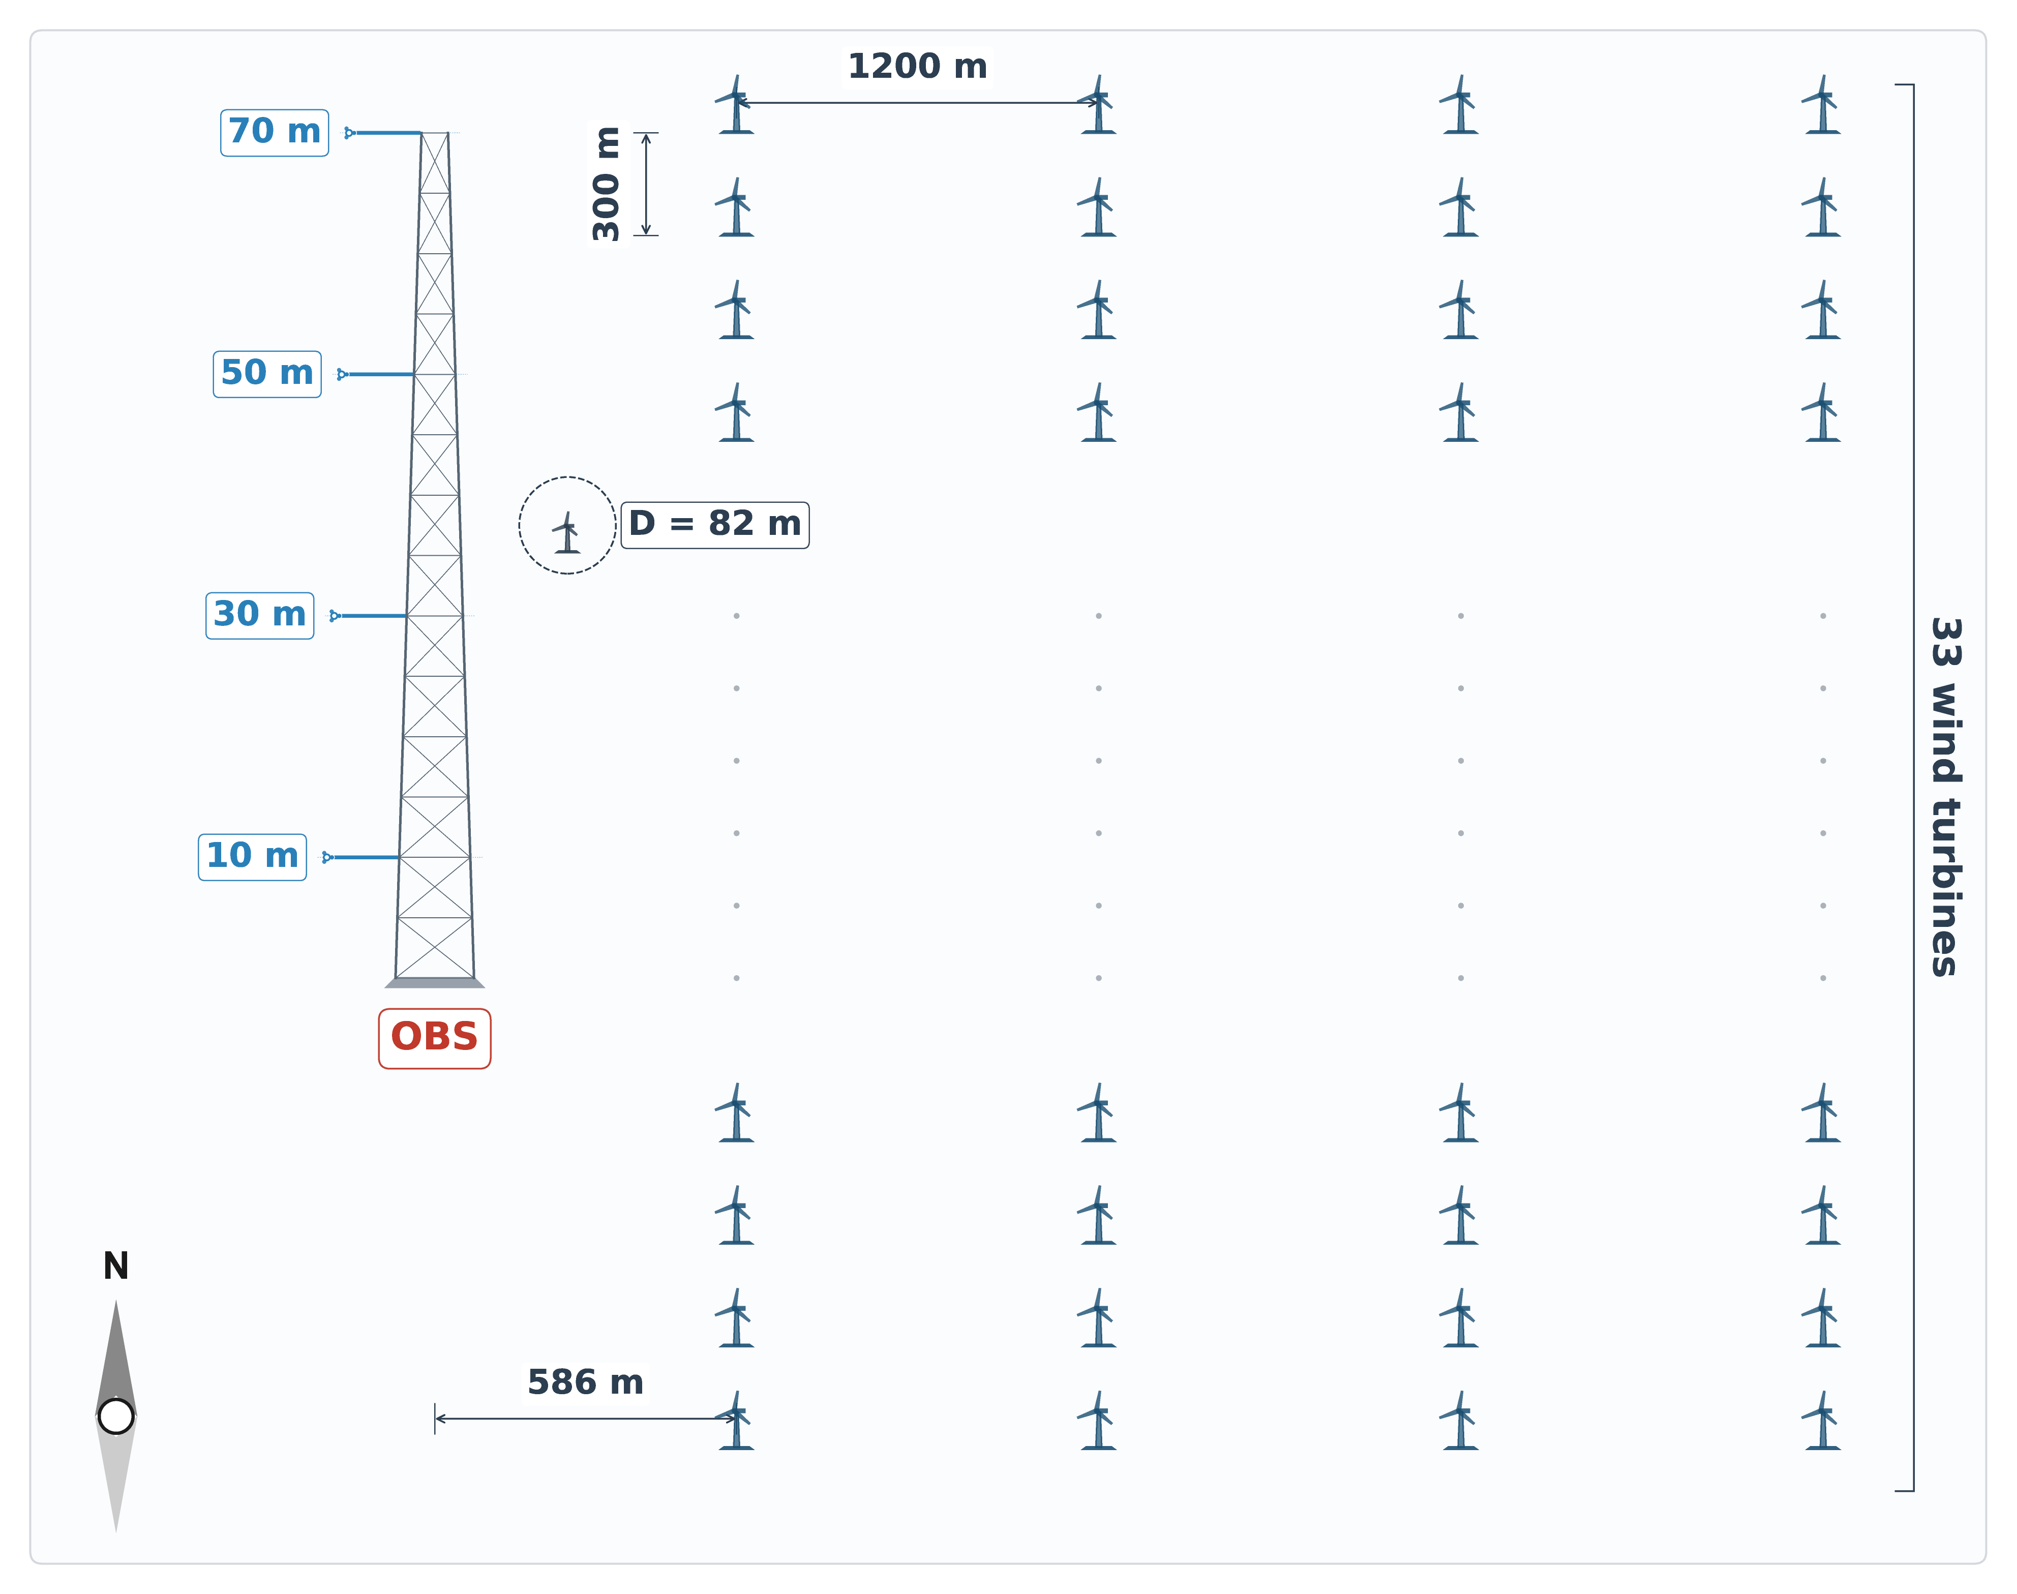

Figure 1. Schematic of the wind farm layout and meteorological mast configuration. The 70-m observation mast (OBS) is located 586 m west of the first turbine column. Wind speed and direction are measured at four heights (10 m, 30 m, 50 m, and 70 m). The farm comprises 134 turbines (33 rows × 4 columns, plus 2 additional turbines) with approximately 300-m row spacing and 1200-m column spacing. Each turbine has a rotor diameter (D) of 82 m and a hub height of 61.5 m. Westerly winds (from left) represent free-stream conditions at the mast, whereas easterly winds (from right) traverse the turbine array before reaching the mast, corresponding to wake-influenced conditions.

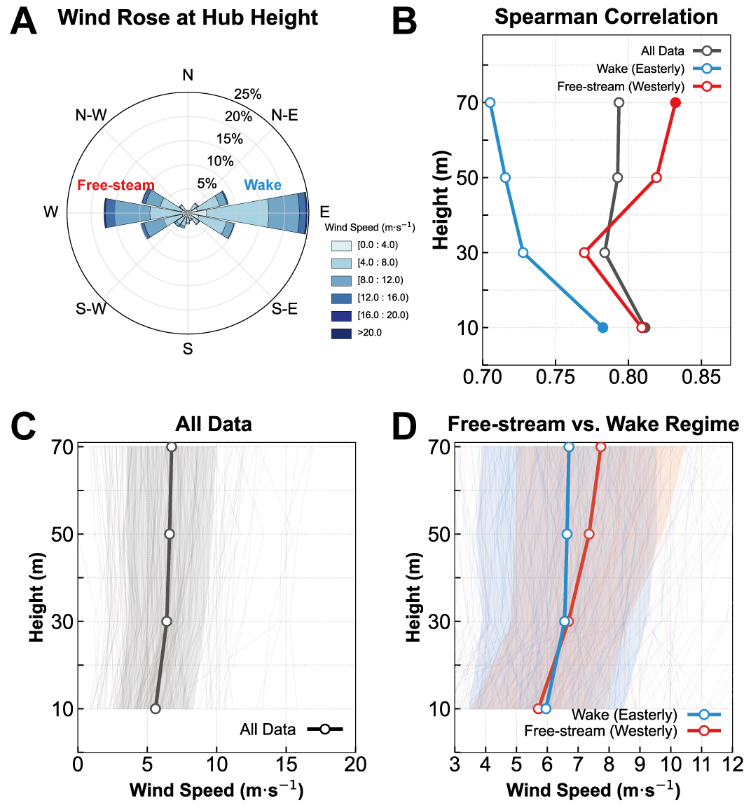

Figure 2. Regime-dependent vertical structure of wind speed and correlation with power production. A: Wind rose at 70-m hub height. The meteorological mast location 586 m west of the first turbine column (33 turbines) enables categorization into westerly free-stream and easterly wake effect sectors. B: Vertical profiles of Spearman correlation between height-specific wind speed and total power output for aggregate dataset (black), free-stream sector (red), and wake effect sector (blue). C: Mean vertical wind speed profile for the entire observation period with background thin lines representing individual instantaneous profiles and gray shading representing one standard deviation (±1σ). D: Comparison of mean vertical wind speed profiles between free-stream (red) and wake effect (blue) regimes with background thin lines showing individual profiles for each regime. Shaded areas denote one standard deviation (±1σ).

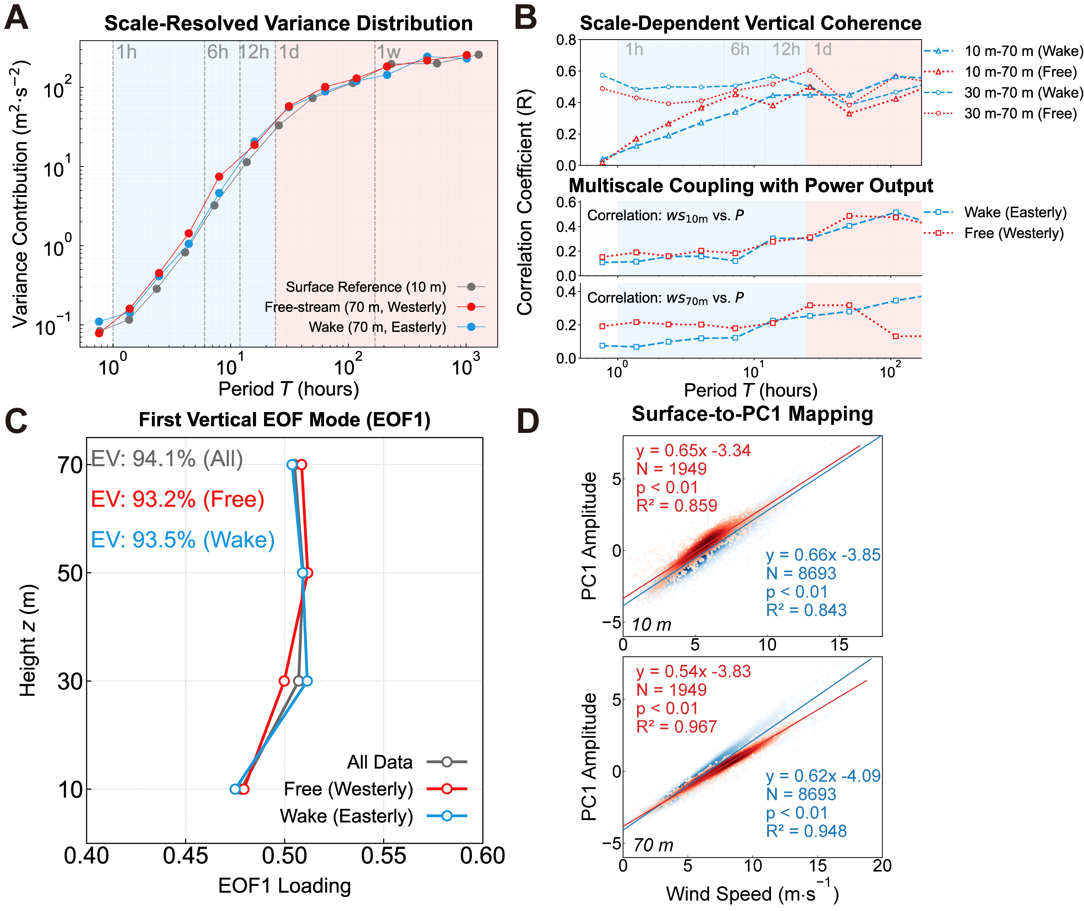

Figure 3. Scale-resolved variance distribution, vertical coherence, and linear relationship between surface wind and vertical profile energy state. A: Scale-resolved variance contribution of wind speed at 10 m (gray) and 70 m for free-stream (red) and wake effect (blue) conditions. Vertical dashed lines indicate temporal periods of 1h, 6h, 12h, 1d, and 1w. B: Scale-dependent vertical coherence and correlation with power output. Top panel shows Spearman correlation coefficient between wind speeds at different height pairs (10-70 m, 30-70 m) as a function of time scale. Bottom panels show Spearman correlation between power output and wind speed at 10 m and 70 m across multiple time scales. Shaded regions differentiate high-frequency and synoptic-scale regimes. C: Vertical profiles of EOF1 loadings for aggregate dataset (gray), free-stream (red), and wake effect (blue) regimes. Explained variance (EV) for each regime is indicated. D: Linear regression between 10-m wind speed (top) or 70-m wind speed (bottom) and PC1 amplitude of the vertical wind profile. Regression statistics including coefficient of determination, sample size, and significance level are shown for free-stream (red) and wake effect (blue) conditions.

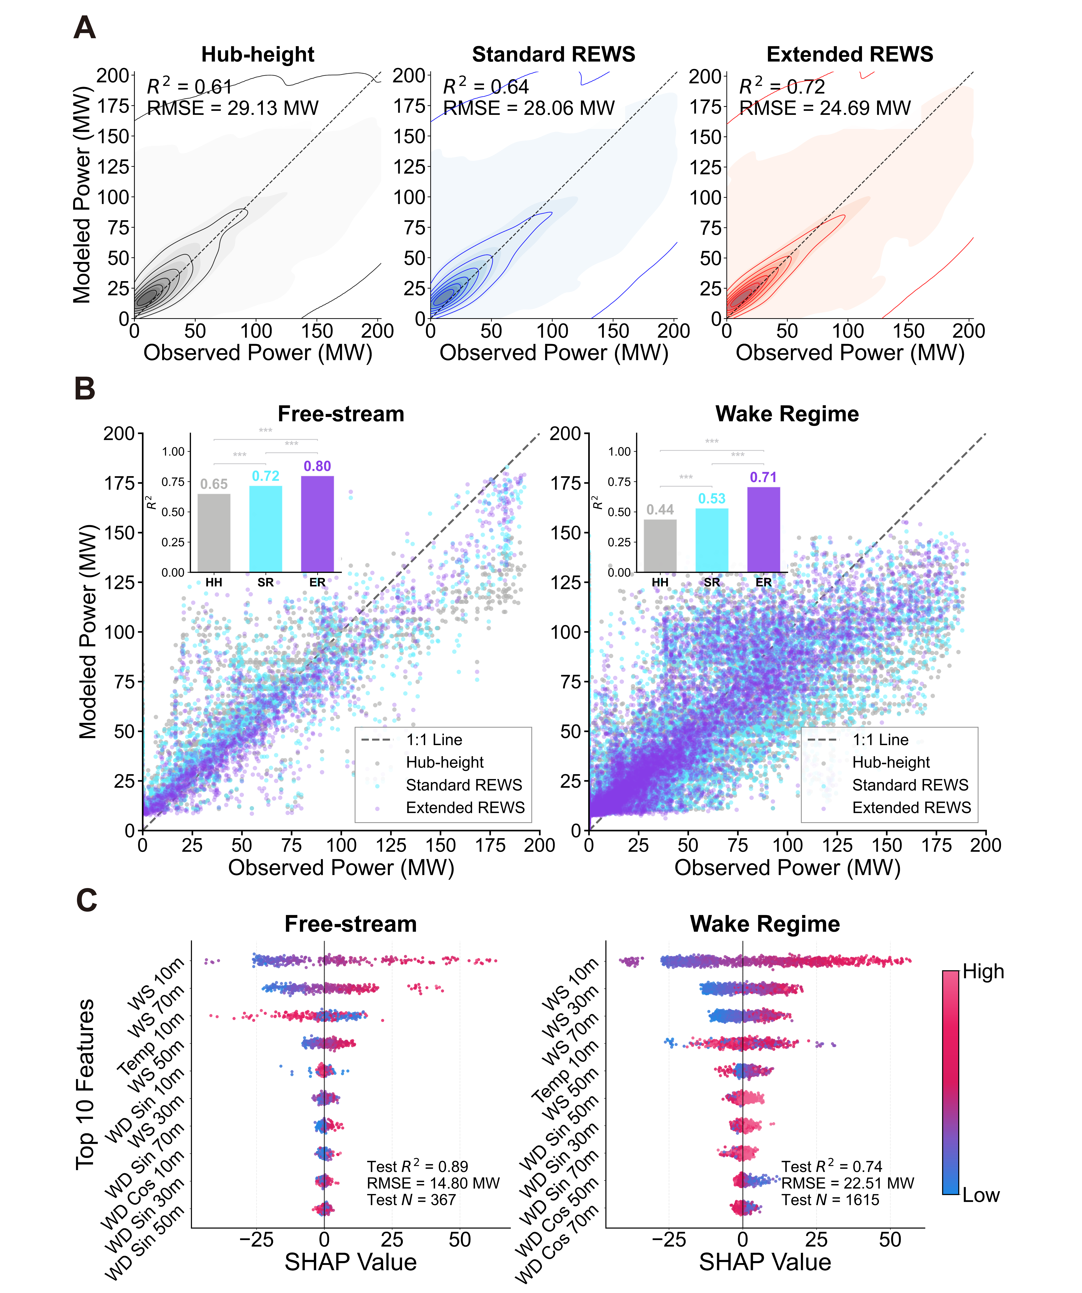

Figure 4. Comparative performance and feature importance analysis of power reconstruction frameworks. A: Density scatter plots comparing observed power with power reconstructed by LightGBM using three input configurations: Hub-height (HH), Standard REWS (SR), and Extended REWS (ER). Coefficient of determination and root-mean-square error are shown for each framework. B: Performance comparison across flow regimes showing coefficient of determination for the three frameworks under free-stream and wake effect conditions. Bar chart insets show significant performance improvement of ER over SR and HH based on Diebold-Mariano tests (***p < 0.01). C: SHAP analysis for the ER model under free-stream and wake effect regimes. Features are ranked by mean absolute SHAP value representing relative importance. Each point represents an individual sample with color indicating feature value magnitude and horizontal position showing impact on power prediction.

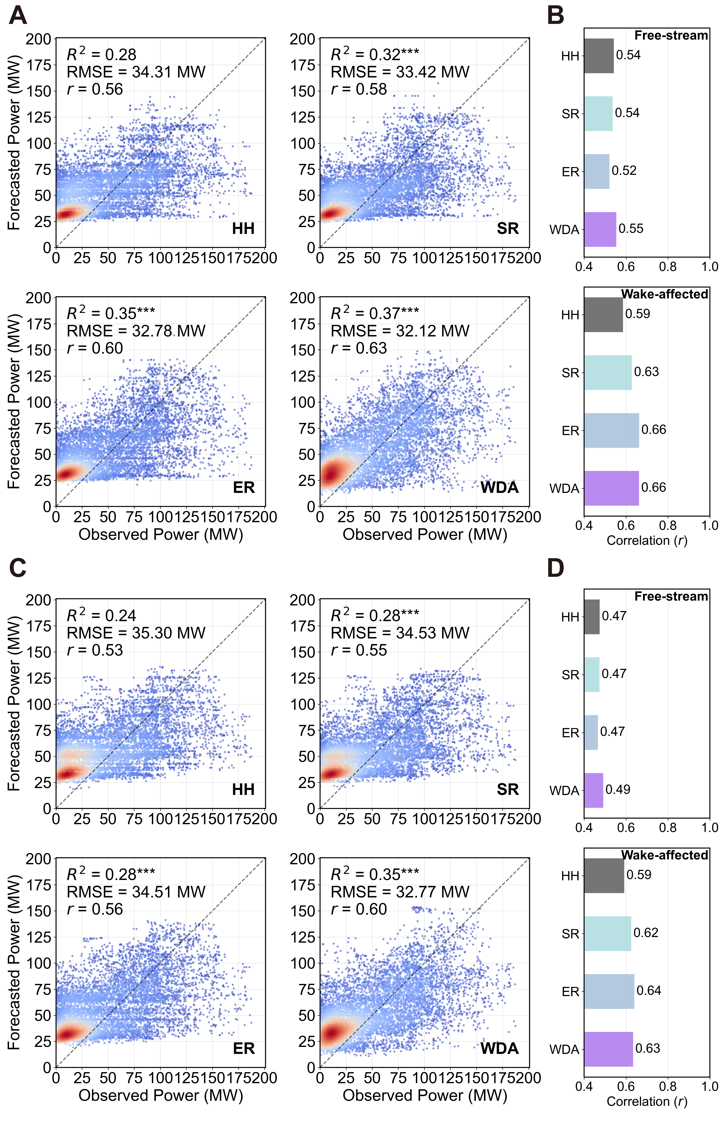

Figure 5. Operational evaluation of WDA strategy for day-ahead power forecasting. A and C: Density scatter plots comparing observed and forecasted power using four configurations: Hub-height (HH), Standard REWS (SR), Extended REWS (ER), and Wind-Direction-Aware (WDA). Results shown for A: EC-WRF and C: GFS-WRF driven forecasts on complete test dataset. Coefficient of determination, root-mean-square error, and correlation coefficient are shown for each configuration. Asterisks (***) indicate statistical significance at p < 0.01 level based on Diebold-Mariano tests relative to HH baseline. B and D: Correlation coefficients across free-stream and wake effect regimes for B: EC-WRF and D: GFS-WRF.

